seconds_in_a_day = 24 * 60 * 60  
seconds_in_a_day

seconds_in_a_week = 7 * seconds_in_a_day  
seconds_in_a_week

import numpy as np  
from matplotlib import pyplot as plt  
  
ys = 200 + np.random.randn(100)  
x = [x for x in range(len(ys))]  
  
plt.plot(x, ys, '-')  
plt.fill_between(x, ys, 195, where=(ys > 195), facecolor='g', alpha=0.6)  
  
plt.title("Sample Visualization")  
plt.show()

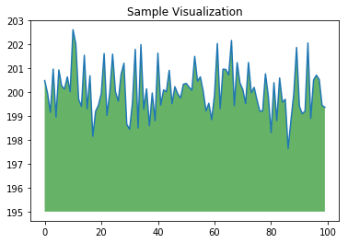

import pandas as pd  
import numpy as np  
import matplotlib.pyplot as plt  
import seaborn as sns

data =pd.read_csv(r'/content/indian_liver_patient.csv')

| **Age** | **Gender** | **Total_Bilirubin** | **Direct_Bilirubin** | **Alkaline_Phosphotase** | **Alamine_Aminotransferase** | **Aspartate_Aminotransferase** | **Total_Protiens** | **Albumin** | **Albumin_and_Globulin_Ratio** | **Dataset** |
| --- | --- | --- | --- | --- | --- | --- | --- | --- | --- | --- |
| 65 | Female | 0.7 | 0.1 | 187 | 16 | 18 | 6.8 | 3.3 | 0.90 | 1 |
| 62 | Male | 10.9 | 5.5 | 699 | 64 | 100 | 7.5 | 3.2 | 0.74 | 1 |
| 62 | Male | 7.3 | 4.1 | 490 | 60 | 68 | 7.0 | 3.3 | 0.89 | 1 |
| 58 | Male | 1.0 | 0.4 | 182 | 14 | 20 | 6.8 | 3.4 | 1.00 | 1 |
| 72 | Male | 3.9 | 2.0 | 195 | 27 | 59 | 7.3 | 2.4 | 0.40 | 1 |

data.shape

<class 'pandas.core.frame.DataFrame'>

RangeIndex: 583 entries, 0 to 582

Data columns (total 11 columns):

# Column Non-Null Count Dtype

--- ------ -------------- -----

0 Age 583 non-null int64

1 Gender 583 non-null object

2 Total_Bilirubin 583 non-null float64

3 Direct_Bilirubin 583 non-null float64

4 Alkaline_Phosphotase 583 non-null int64

5 Alamine_Aminotransferase 583 non-null int64

6 Aspartate_Aminotransferase 583 non-null int64

7 Total_Protiens 583 non-null float64

8 Albumin 583 non-null float64

9 Albumin_and_Globulin_Ratio 579 non-null float64

10 Dataset 583 non-null int64

dtypes: float64(5), int64(5), object(1)

memory usage: 50.2+ KB

data.drop_duplicates()

|  | **count** | **mean** | **std** | **min** | **25%** | **50%** | **75%** | **max** |
| --- | --- | --- | --- | --- | --- | --- | --- | --- |
| **Age** | 583.0 | 44.746141 | 16.189833 | 4.0 | 33.0 | 45.00 | 58.0 | 90.0 |
| **Total_Bilirubin** | 583.0 | 3.298799 | 6.209522 | 0.4 | 0.8 | 1.00 | 2.6 | 75.0 |
| **Direct_Bilirubin** | 583.0 | 1.486106 | 2.808498 | 0.1 | 0.2 | 0.30 | 1.3 | 19.7 |
| **Alkaline_Phosphotase** | 583.0 | 290.576329 | 242.937989 | 63.0 | 175.5 | 208.00 | 298.0 | 2110.0 |
| **Alamine_Aminotransferase** | 583.0 | 80.713551 | 182.620356 | 10.0 | 23.0 | 35.00 | 60.5 | 2000.0 |
| **Aspartate_Aminotransferase** | 583.0 | 109.910806 | 288.918529 | 10.0 | 25.0 | 42.00 | 87.0 | 4929.0 |
| **Total_Protiens** | 583.0 | 6.483190 | 1.085451 | 2.7 | 5.8 | 6.60 | 7.2 | 9.6 |
| **Albumin** | 583.0 | 3.141852 | 0.795519 | 0.9 | 2.6 | 3.10 | 3.8 | 5.5 |
| **Albumin_and_Globulin_Ratio** | 579.0 | 0.947064 | 0.319592 | 0.3 | 0.7 | 0.93 | 1.1 | 2.8 |
| **Dataset** | 583.0 | 1.286449 | 0.452490 | 1.0 | 1.0 | 1.00 | 2.0 | 2.0 |
|  |  |  |  |  |  |  |  |  |

data.describe().transpose()

Age 0

Gender 0

Total_Bilirubin 0

Direct_Bilirubin 0

Alkaline_Phosphotase 0

Alamine_Aminotransferase 0

Aspartate_Aminotransferase 0

Total_Protiens 0

Albumin 0

Albumin_and_Globulin_Ratio 4

Dataset 0

dtype: int64

data.duplicated().sum()

|  | **Age** | **Gender** | **Total_Bilirubin** | **Direct_Bilirubin** | **Alkaline_Phosphotase** | **Alamine_Aminotransferase** | **Aspartate_Aminotransferase** | **Total_Protiens** | **Albumin** | **Albumin_and_Globulin_Ratio** | **Dataset** |
| --- | --- | --- | --- | --- | --- | --- | --- | --- | --- | --- | --- |
| **0** | **65** | **Female** | **0.7** | **0.1** | **187** | **16** | **18** | **6.8** | **3.3** | **0.90** | **1** |
| **1** | **62** | **Male** | **10.9** | **5.5** | **699** | **64** | **100** | **7.5** | **3.2** | **0.74** | **1** |
| **2** | **62** | **Male** | **7.3** | **4.1** | **490** | **60** | **68** | **7.0** | **3.3** | **0.89** | **1** |
| **3** | **58** | **Male** | **1.0** | **0.4** | **182** | **14** | **20** | **6.8** | **3.4** | **1.00** | **1** |
| **4** | **72** | **Male** | **3.9** | **2.0** | **195** | **27** | **59** | **7.3** | **2.4** | **0.40** | **1** |
| **...** | **...** | **...** | **...** | **...** | **...** | **...** | **...** | **...** | **...** | **...** | **...** |
| **578** | **60** | **Male** | **0.5** | **0.1** | **500** | **20** | **34** | **5.9** | **1.6** | **0.37** | **2** |
| **579** | **40** | **Male** | **0.6** | **0.1** | **98** | **35** | **31** | **6.0** | **3.2** | **1.10** | **1** |
| **580** | **52** | **Male** | **0.8** | **0.2** | **245** | **48** | **49** | **6.4** | **3.2** | **1.00** | **1** |
| **581** | **31** | **Male** | **1.3** | **0.5** | **184** | **29** | **32** | **6.8** | **3.4** | **1.00** | **1** |
| **582** | **38** | **Male** | **1.0** | **0.3** | **216** | **21** | **24** | **7.3** | **4.4** | **1.50** | **2** |

data.Dataset.value_counts()

1 416

2 167

Name: Dataset, dtype: int64

data.shape

(583, 11)

data['Age'].describe()

count 583.000000

mean 44.746141

std 16.189833

min 4.000000

25% 33.000000

50% 45.000000

75% 58.000000

max 90.000000

Name: Age, dtype: float64

data['Age'].describe()

count 583.000000

mean 44.746141

std 16.189833

min 4.000000

25% 33.000000

50% 45.000000

75% 58.000000

max 90.000000

Name: Age, dtype: float64

plt.figure(figsize=[12,3])  
sns.boxplot(x = 'Age', data = data,color='maroon')  
plt.title('Boxplot for Age Variable')  
plt.show()

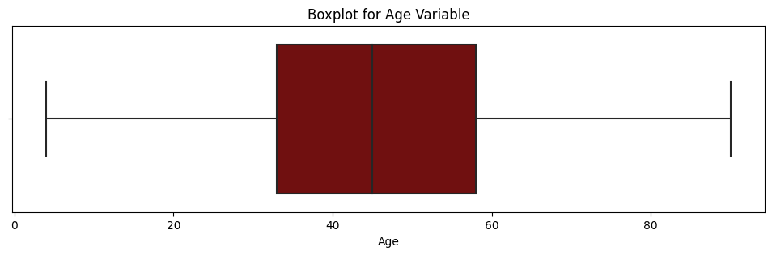

plt.figure(figsize=[12,3])

sns.boxplot(x = 'Age', data = data,color='maroon')

plt.title('Boxplot for Age Variable')

plt.show()

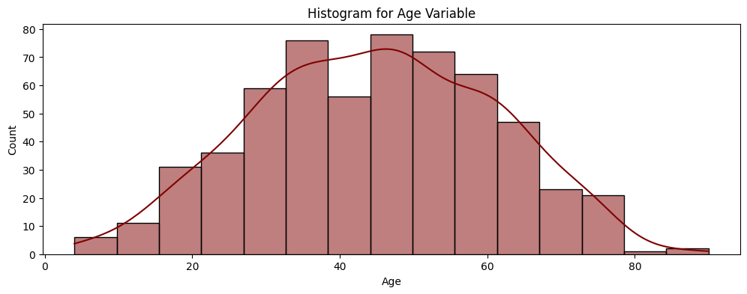

plt.figure(figsize=[12,4])

sns.histplot(data = data['Age'], kde = True,color='maroon')

plt.title('Histogram for Age Variable')

plt.show()

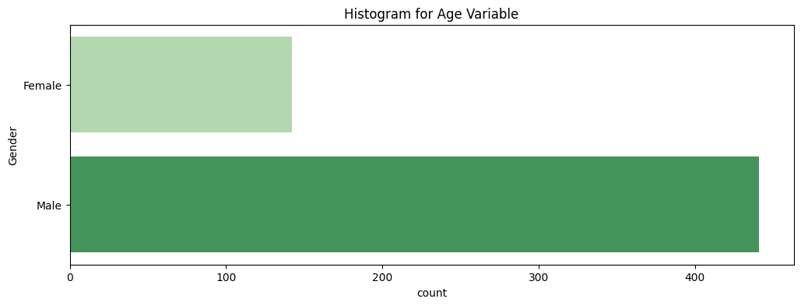

plt.figure(figsize=[12,4])

sns.countplot(y = data['Gender'],palette='Greens')

plt.title('Histogram for Age Variable')

plt.show()



plt.figure(figsize=[12,4])

sns.histplot(data = data['Total_Bilirubin'], kde = True,color='maroon')

plt.title('Histogram for Total_Bilirubin Variable')

plt.show()

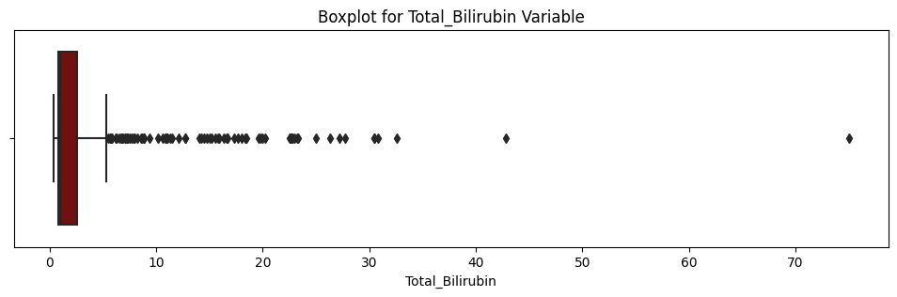

plt.figure(figsize=[12,4])

sns.histplot(data = data['Direct_Bilirubin'], kde = True,color='maroon')

plt.title('Histogram for Direct_Bilirubin Variable')

plt.show()

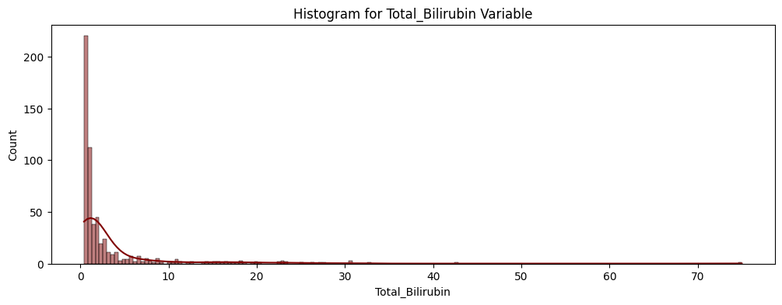plt.figure(figsize=[12,3])

sns.boxplot(x = 'Alkaline_Phosphotase', data = data,color='maroon')

plt.title('Boxplot for Alkaline_Phosphotase Variable')

plt.show()

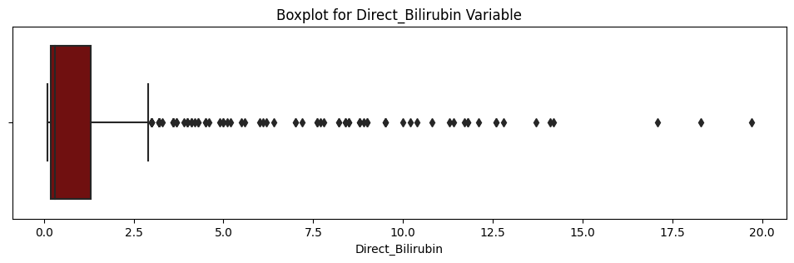

plt.figure(figsize=[12,4])

sns.histplot(data = data['Alkaline_Phosphotase'], kde = True,color='maroon')

plt.title('Histogram for Alkaline_Phosphotase Variable')

plt.show()

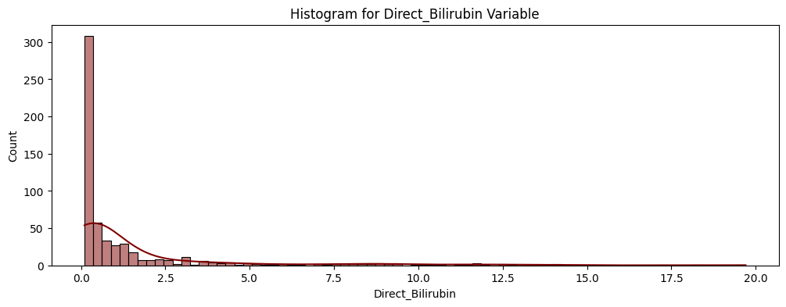

plt.figure(figsize=[12,4])

sns.histplot(data = data['Alamine_Aminotransferase'], kde = True,color='maroon')

plt.title('Histogram for Alamine_Aminotransferase Variable')

plt.show()

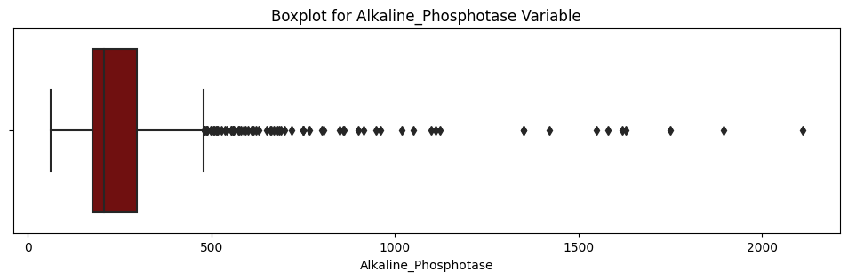

plt.figure(figsize=[12,3])

sns.boxplot(x = 'Alamine_Aminotransferase', data = data,color='maroon')

plt.title('Boxplot for Alamine_Aminotransferase Variable')

plt.show()

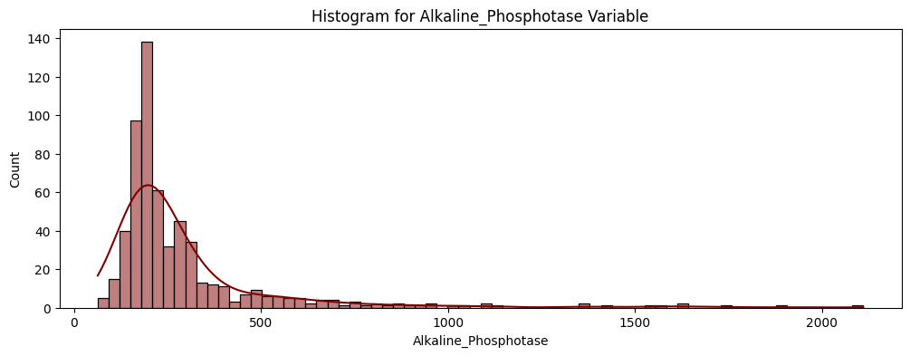

plt.figure(figsize=[12,4])

sns.histplot(data = data['Aspartate_Aminotransferase'], kde = True,color='maroon')

plt.title('Histogram for Aspartate_Aminotransferase Variable')

plt.show()

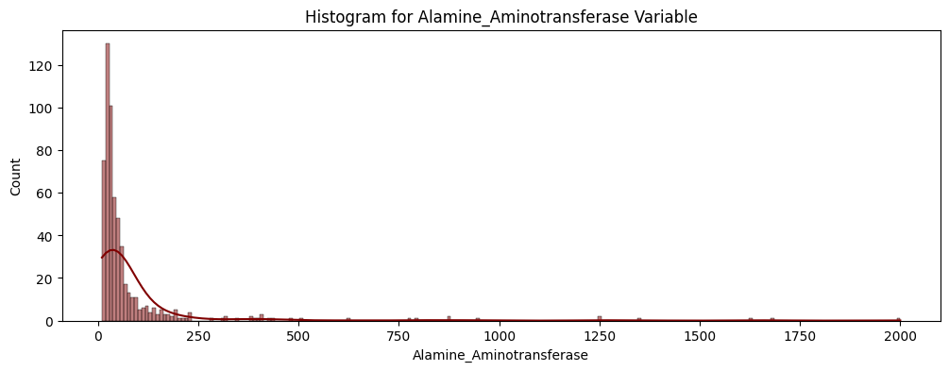

plt.figure(figsize=[12,3])

sns.boxplot(x = 'Aspartate_Aminotransferase', data = data,color='maroon')

plt.title('Boxplot for Aspartate_Aminotransferase Variable')

plt.show()

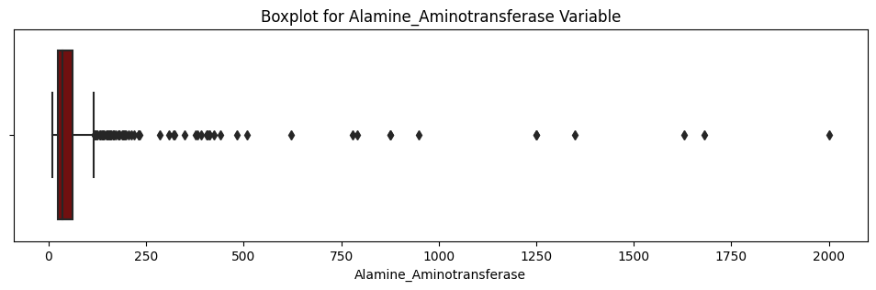

plt.figure(figsize=[12,4])

sns.histplot(data = data['Total_Protiens'], kde = True,color='maroon')

plt.title('Histogram for Total_Protiens Variable')

plt.show()

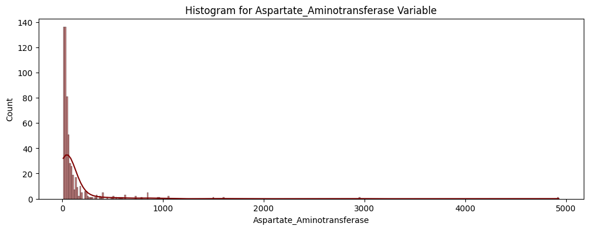

plt.figure(figsize=[12,3])

sns.boxplot(x = 'Total_Protiens', data = data,color='maroon')

plt.title('Boxplot for Total_Protiens Variable')

plt.show()

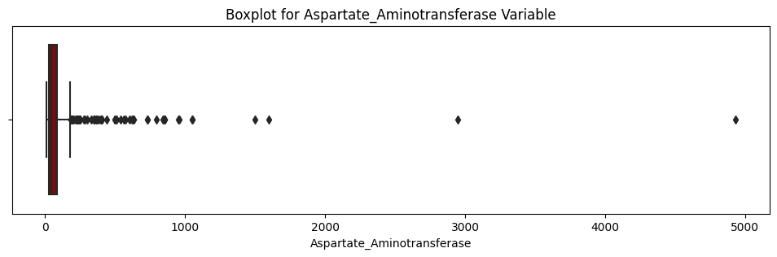

plt.figure(figsize=[12,4])

sns.histplot(data = data['Albumin'], kde = True,color='maroon')

plt.title('Histogram for Albumin Variable')

plt.show()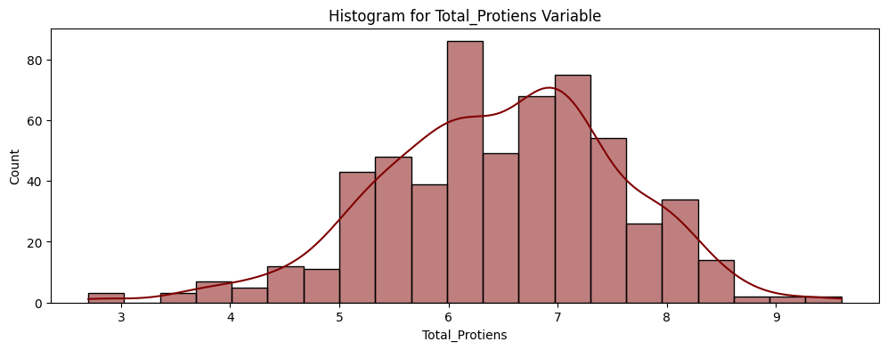

plt.figure(figsize=[12,3])

sns.boxplot(x = 'Albumin', data = data,color='maroon')

plt.title('Boxplot for Albumin Variable')

plt.show()

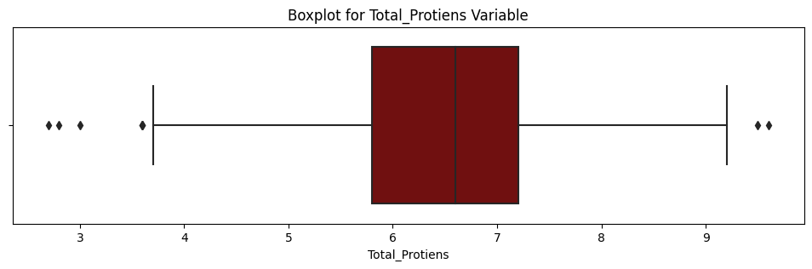

plt.figure(figsize=[12,4])

sns.histplot(data = data['Albumin_and_Globulin_Ratio'], kde = True,color='maroon')

plt.title('Histogram for Albumin_and_Globulin_Ratio Variable')

plt.show()

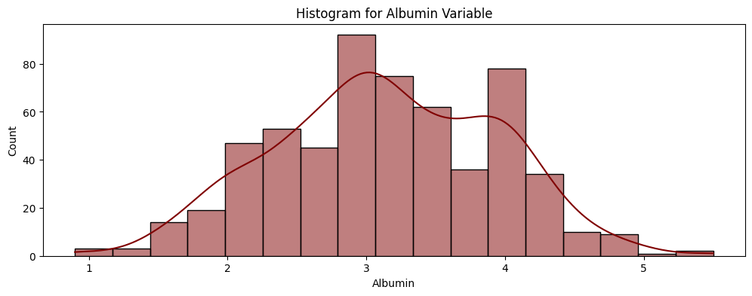

plt.figure(figsize=[12,3])

sns.boxplot(x = 'Albumin_and_Globulin_Ratio', data = data,color='maroon')

plt.title('Boxplot for Albumin_and_Globulin_Ratio Variable')

plt.show()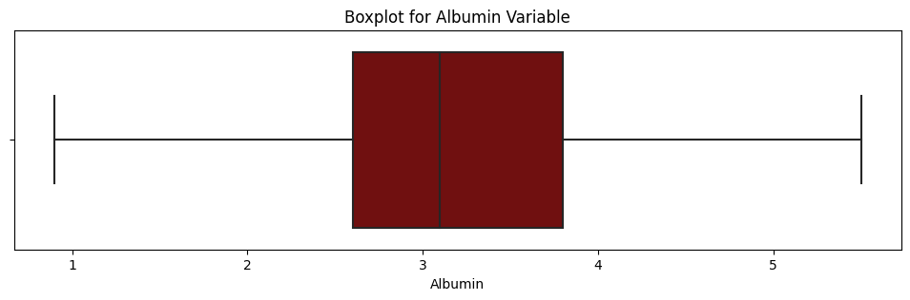

plt.figure(figsize=[12,4])

sns.countplot(y = data['Dataset'],palette='Greens')

plt.title('countplot for Dataset Variable')

plt.show()

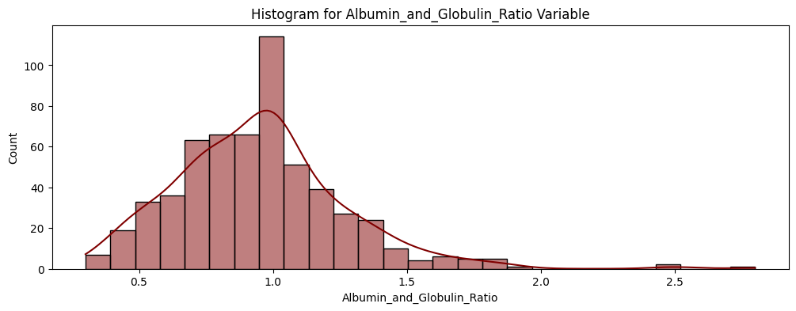

data.corr()

plt.figure(figsize = [20,8])

sns.heatmap(data.corr(),annot=True,cmap='magma', vmin=-1, vmax=1)

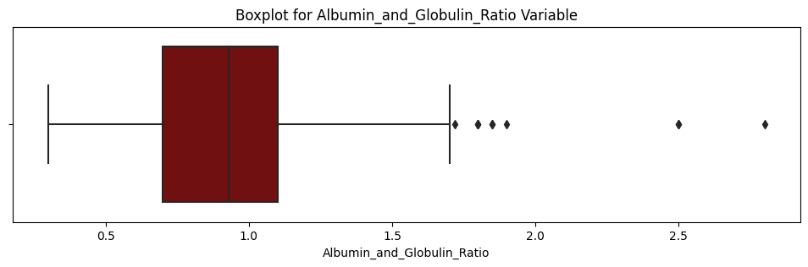

plt.figure(figsize=[12,4])

sns.countplot(x = data['Dataset'],hue=data['Gender'],palette='magma')

plt.title('countplot for Dataset Variable')

plt.show()

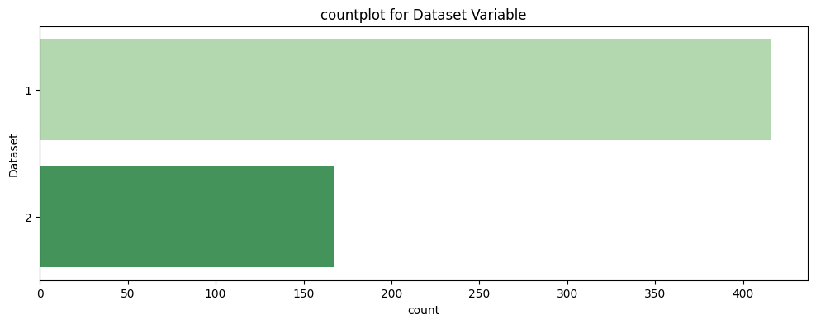

data.info()

|  | **Age** | **Total_Bilirubin** | **Direct_Bilirubin** | **Alkaline_Phosphotase** | **Alamine_Aminotransferase** | **Aspartate_Aminotransferase** | **Total_Protiens** | **Albumin** | **Albumin_and_Globulin_Ratio** | **Dataset** |
| --- | --- | --- | --- | --- | --- | --- | --- | --- | --- | --- |
| **Age** | 1.000000 | 0.011763 | 0.007529 | 0.080425 | -0.086883 | -0.019910 | -0.187461 | -0.265924 | -0.216408 | -0.137351 |
| **Total_Bilirubin** | 0.011763 | 1.000000 | 0.874618 | 0.206669 | 0.214065 | 0.237831 | -0.008099 | -0.222250 | -0.206267 | -0.220208 |
| **Direct_Bilirubin** | 0.007529 | 0.874618 | 1.000000 | 0.234939 | 0.233894 | 0.257544 | -0.000139 | -0.228531 | -0.200125 | -0.246046 |
| **Alkaline_Phosphotase** | 0.080425 | 0.206669 | 0.234939 | 1.000000 | 0.125680 | 0.167196 | -0.028514 | -0.165453 | -0.234166 | -0.184866 |
| **Alamine_Aminotransferase** | -0.086883 | 0.214065 | 0.233894 | 0.125680 | 1.000000 | 0.791966 | -0.042518 | -0.029742 | -0.002375 | -0.163416 |
| **Aspartate_Aminotransferase** | -0.019910 | 0.237831 | 0.257544 | 0.167196 | 0.791966 | 1.000000 | -0.025645 | -0.085290 | -0.070040 | -0.151934 |
| **Total_Protiens** | -0.187461 | -0.008099 | -0.000139 | -0.028514 | -0.042518 | -0.025645 | 1.000000 | 0.784053 | 0.234887 | 0.035008 |
| **Albumin** | -0.265924 | -0.222250 | -0.228531 | -0.165453 | -0.029742 | -0.085290 | 0.784053 | 1.000000 | 0.689632 | 0.161388 |
| **Albumin_and_Globulin_Ratio** | -0.216408 | -0.206267 | -0.200125 | -0.234166 | -0.002375 | -0.070040 | 0.234887 | 0.689632 | 1.000000 | 0.163131 |
| **Dataset** | -0.137351 | -0.220208 | -0.246046 | -0.184866 | -0.163416 | -0.151934 | 0.035008 | 0.161388 | 0.163131 | 1.000000 |

plt.figure(figsize = [20,8])  
sns.heatmap(data.corr(),annot=True,cmap='magma', vmin=-1, vmax=1)

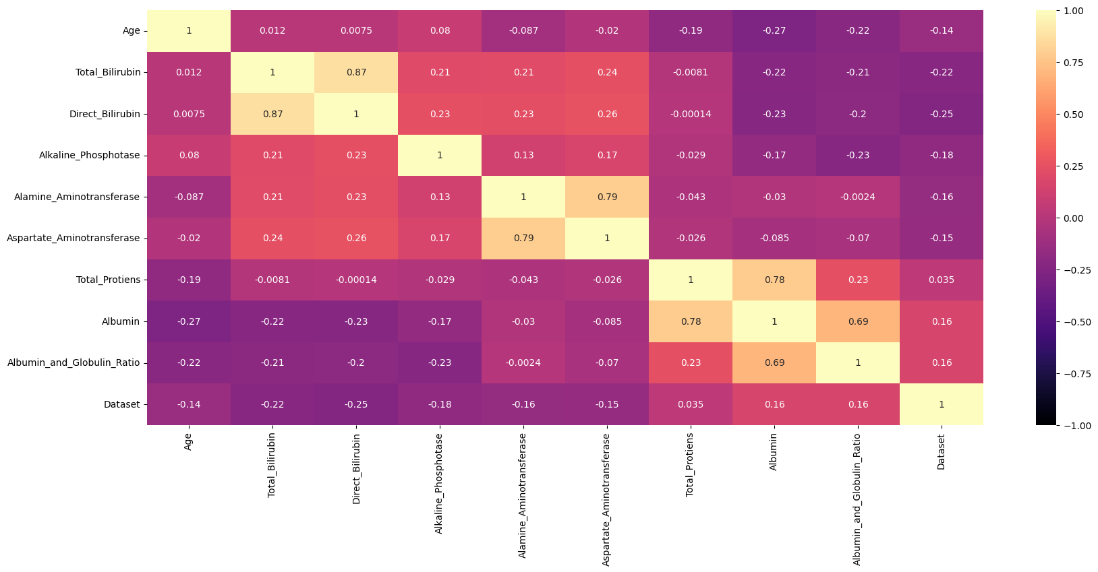

plt.figure(figsize=[12,4])

sns.countplot(x = data['Dataset'],hue=data['Gender'],palette='magma')

plt.title('countplot for Dataset Variable')

plt.show()

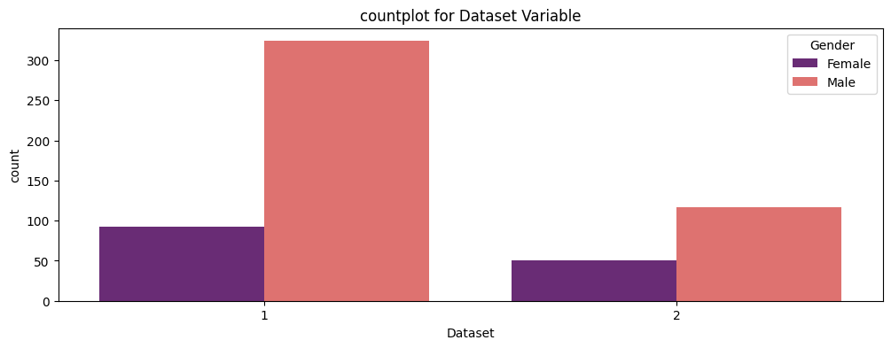

data.info()

<class 'pandas.core.frame.DataFrame'>

RangeIndex: 583 entries, 0 to 582

Data columns (total 11 columns):

# Column Non-Null Count Dtype

--- ------ -------------- -----

0 Age 583 non-null int64

1 Gender 583 non-null object

2 Total_Bilirubin 583 non-null float64

3 Direct_Bilirubin 583 non-null float64

4 Alkaline_Phosphotase 583 non-null int64

5 Alamine_Aminotransferase 583 non-null int64

6 Aspartate_Aminotransferase 583 non-null int64

7 Total_Protiens 583 non-null float64

8 Albumin 583 non-null float64

9 Albumin_and_Globulin_Ratio 579 non-null float64

10 Dataset 583 non-null int64

dtypes: float64(5), int64(5), object(1)

memory usage: 50.2+ KB

var_list=['Total_Bilirubin', 'Direct_Bilirubin',

'Alkaline_Phosphotase', 'Alamine_Aminotransferase',

'Aspartate_Aminotransferase', 'Total_Protiens', 'Albumin',

'Albumin_and_Globulin_Ratio']

def draw_scattterplots(df, variables, n_rows, n_cols):

fig=plt.figure(figsize = [20,20])

for i, var_name **in** enumerate(variables):

ax=fig.add_subplot(n_rows,n_cols,i+1)

sns.scatterplot(x=df[var_name],y=df[var_name],ax=ax)

ax.set_title(var_name+" Distribution")

fig.tight_layout() *# Improves appearance a bit.*

plt.show()

*#test = pd.DataFrame(np.random.randn(30, 9), columns=map(str, range(9)))*

draw_scattterplots(data, data[var_list],8,4)

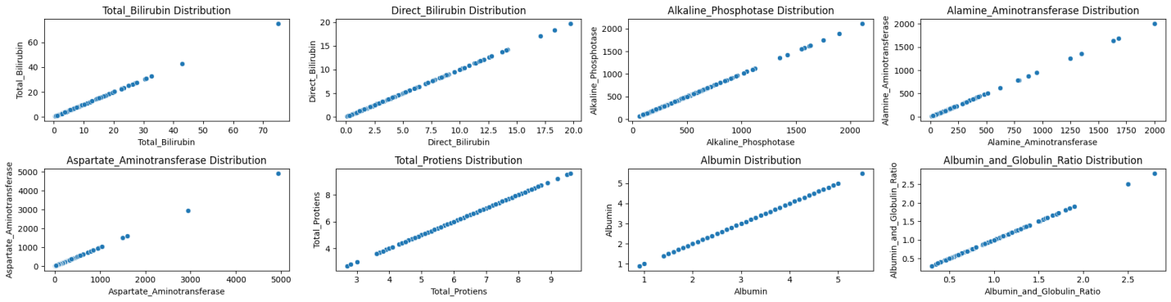

plt.figure(figsize=[12,4])

sns.scatterplot(x = data['Total_Bilirubin'],y=data['Direct_Bilirubin'],hue=data['Dataset'],palette='deep')

plt.title('Billirunin (Direct Vs Total)')

plt.show()

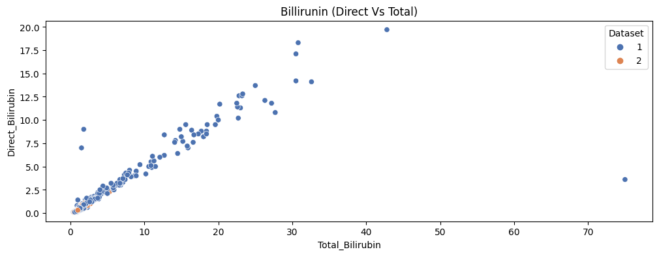

plt.figure(figsize=[12,4])

sns.scatterplot(x = data['Total_Bilirubin'],y=data['Alkaline_Phosphotase'],hue=data['Dataset'],palette='deep')

plt.title('Billirunin Vs Alkaline_Phosphotase')

plt.show()

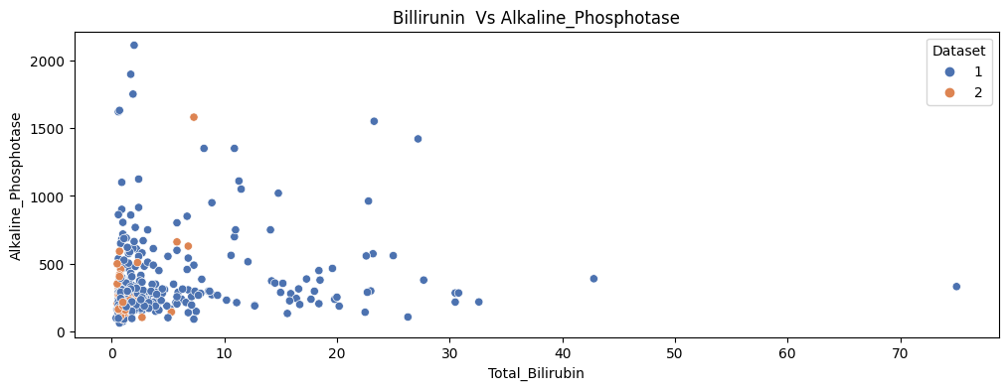

plt.figure(figsize=[12,4])

sns.scatterplot(x = data['Total_Bilirubin'],y=data['Alamine_Aminotransferase'],hue=data['Dataset'],palette='deep')

plt.title('Billirunin Vs Alamine_Aminotransferase')

plt.show()plt.figure(figsize=[12,4])

sns.scatterplot(x = data['Total_Bilirubin'],y=data['Direct_Bilirubin'],hue=data['Dataset'],palette='deep')

plt.title('Billirunin (Direct Vs Total)')

plt.show()

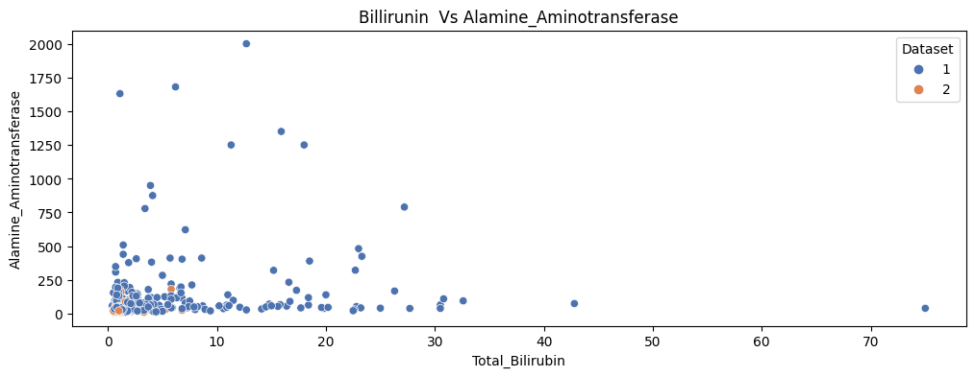

plt.figure(figsize=[12,4])

sns.scatterplot(x = data['Total_Bilirubin'],y=data['Alkaline_Phosphotase'],hue=data['Dataset'],palette='deep')

plt.title('Billirunin Vs Alkaline_Phosphotase')

plt.show()

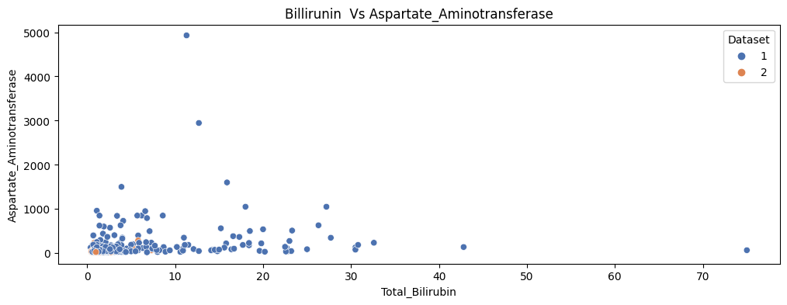

plt.figure(figsize=[12,4])

sns.scatterplot(x = data['Total_Bilirubin'],y=data['Alamine_Aminotransferase'],hue=data['Dataset'],palette='deep') 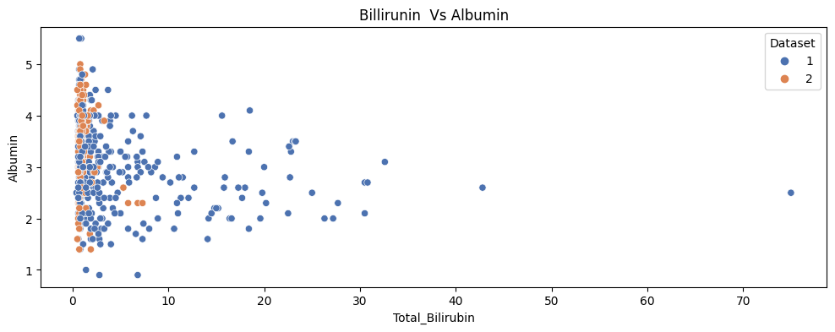

plt.figure(figsize=[12,4])

sns.scatterplot(x = data['Total_Bilirubin'],y=data['Aspartate_Aminotransferase'],hue=data['Dataset'],palette='deep')

plt.title('Billirunin Vs Aspartate_Aminotransferase')

plt.show()

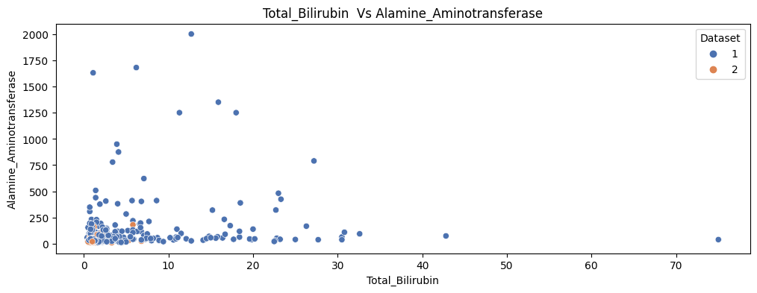

plt.figure(figsize=[12,4])

sns.scatterplot(x = data['Total_Bilirubin'],y=data['Total_Protiens'],hue=data['Dataset'],palette='deep')

plt.title('Billirunin Vs Total_Protiens')

plt.show()

plt.figure(figsize=[12,4])

sns.scatterplot(x = data['Total_Bilirubin'],y=data['Albumin'],hue=data['Dataset'],palette='deep')

plt.title('Billirunin Vs Albumin')

plt.show()



plt.figure(figsize=[12,4])

sns.scatterplot(x = data['Total_Bilirubin'],y=data['Albumin_and_Globulin_Ratio'],hue=data['Dataset'],palette='deep')

plt.title('Billirunin Vs Albumin_and_Globulin_Ratio')

plt.show()

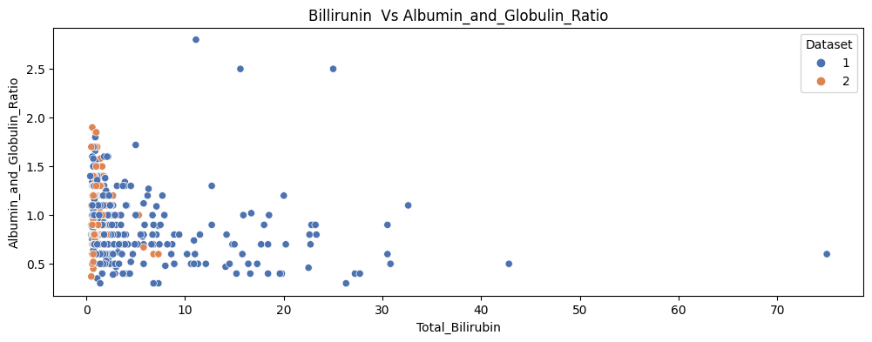

plt.figure(figsize=[12,4])

sns.scatterplot(x = data['Direct_Bilirubin'],y=data['Alamine_Aminotransferase'],hue=data['Dataset'],palette='deep')

plt.title('Direct_Bilirubin Vs Alkaline_Phosphotase')

plt.show()

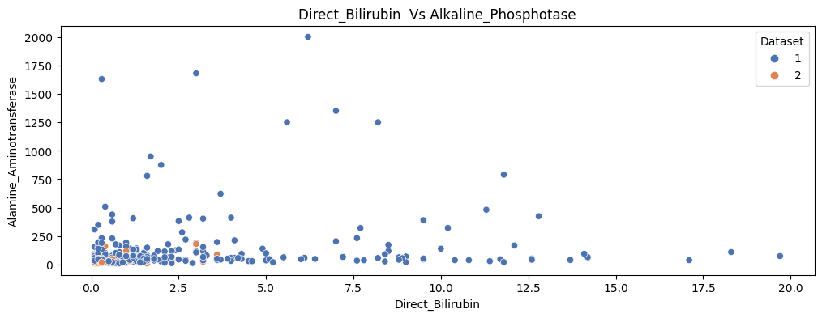

plt.figure(figsize=[12,4])

sns.scatterplot(x = data['Total_Bilirubin'],y=data['Alamine_Aminotransferase'],hue=data['Dataset'],palette='deep')

plt.title('Total_Bilirubin Vs Alamine_Aminotransferase')

plt.show()

plt.figure(figsize=[12,4])

sns.scatterplot(x = data['Total_Bilirubin'],y=data['Aspartate_Aminotransferase'],hue=data['Dataset'],palette='deep')

plt.title('Total_Bilirubin Vs Aspartate_Aminotransferase')

plt.show()

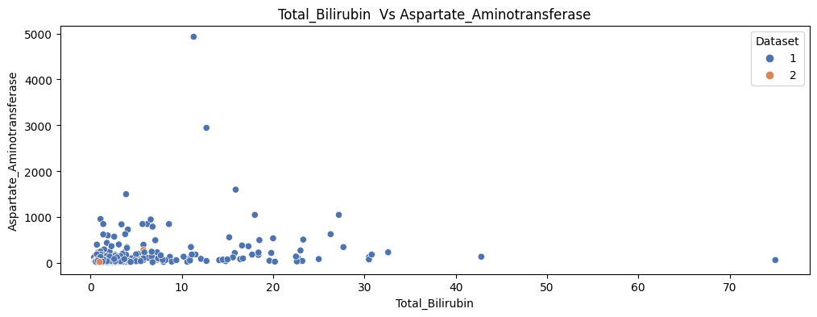

plt.figure(figsize=[12,4])

sns.scatterplot(x = data['Total_Bilirubin'],y=data['Albumin'],hue=data['Dataset'],palette='deep')

plt.title('Total_Bilirubin Vs Albumin')

plt.show()

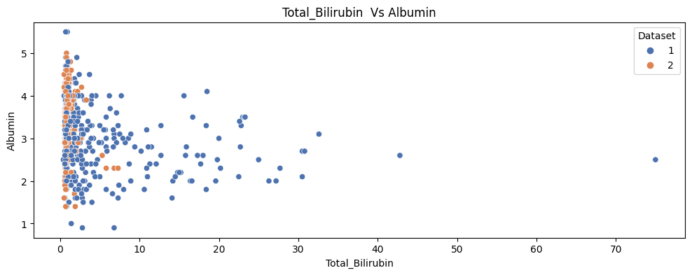

plt.figure(figsize=[12,4])

sns.scatterplot(x = data['Alkaline_Phosphotase'],y=data['Total_Protiens'],hue=data['Dataset'],palette='deep')

plt.title('Alkaline_Phosphotase Vs Total_Protiens')

plt.show()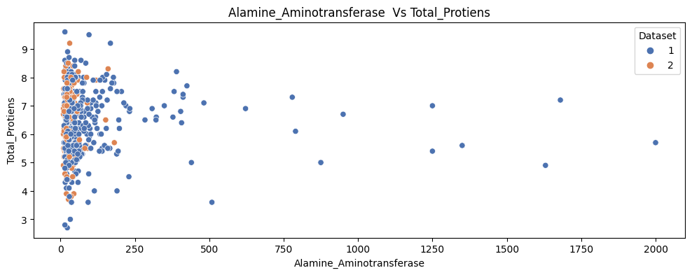

plt.figure(figsize=[12,4])

sns.scatterplot(x = data['Alkaline_Phosphotase'],y=data['Albumin'],hue=data['Dataset'],palette='deep')

plt.title('Alkaline_Phosphotase Vs Albumin')

plt.show()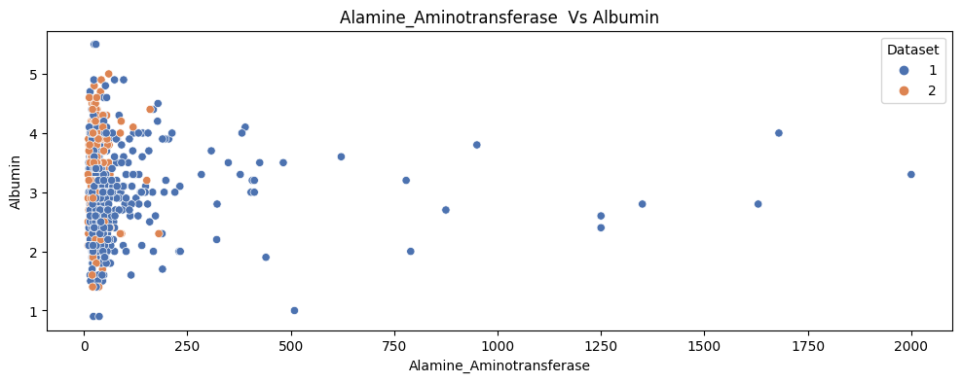

plt.figure(figsize=[12,4])

sns.scatterplot(x = data['Alkaline_Phosphotase'],y=data['Albumin_and_Globulin_Ratio'],hue=data['Dataset'],palette='deep')

plt.title('Alkaline_Phosphotase Vs Albumin_and_Globulin_Ratio')

plt.show()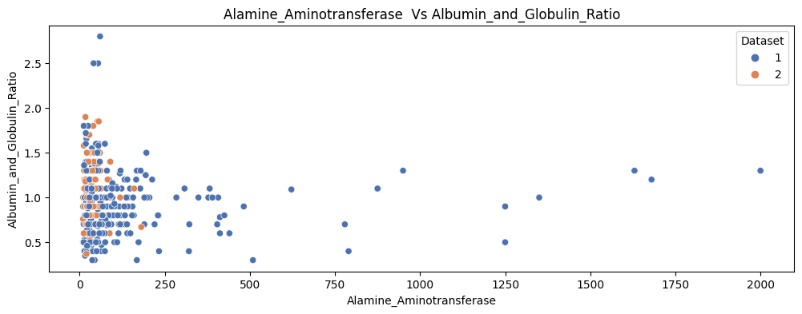

plt.figure(figsize=[12,4])

sns.scatterplot(x = data['Alamine_Aminotransferase'],y=data['Aspartate_Aminotransferase'],hue=data['Dataset'],palette='deep')

plt.title('Alamine_Aminotransferase Vs Aspartate_Aminotransferase')

plt.show()

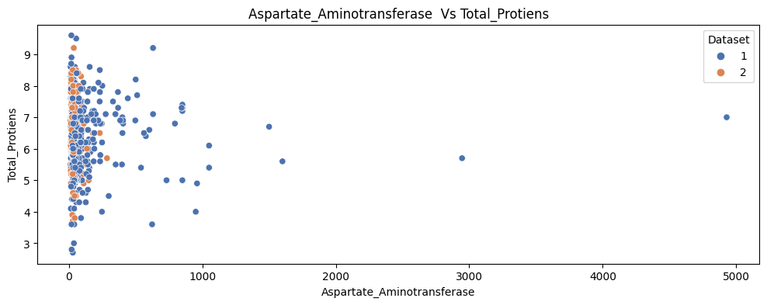

plt.figure(figsize=[12,4])

sns.scatterplot(x = data['Aspartate_Aminotransferase'],y=data['Albumin'],hue=data['Dataset'],palette='deep')

plt.title('Aspartate_Aminotransferase Vs Albumin')

plt.show()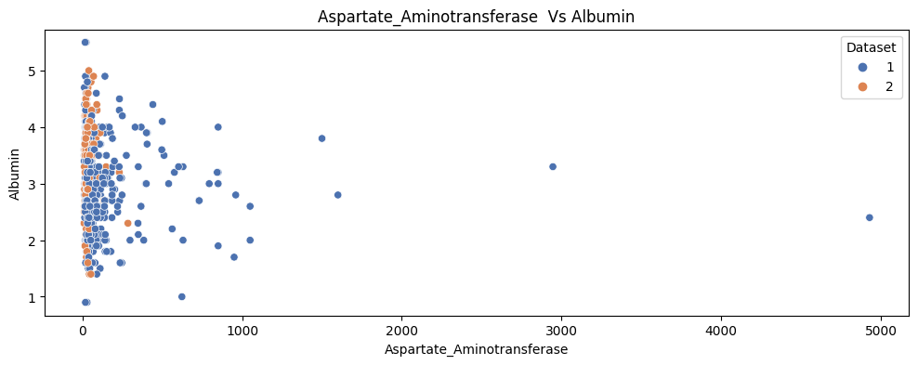

plt.figure(figsize=[12,4])

sns.scatterplot(x = data['Aspartate_Aminotransferase'],y=data['Albumin_and_Globulin_Ratio'],hue=data['Dataset'],palette='deep')

plt.title('Aspartate_Aminotransferase Vs Albumin_and_Globulin_Ratio')

plt.show()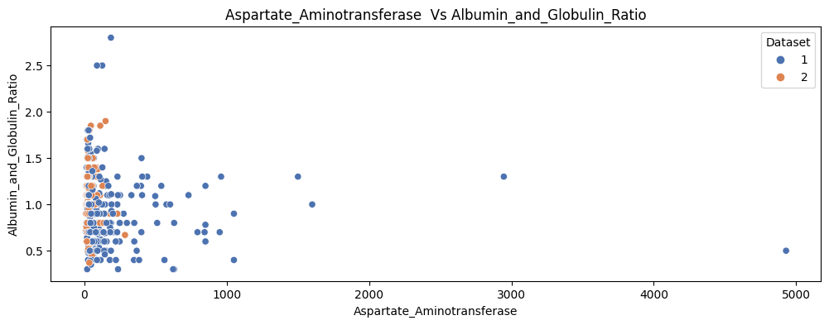

plt.figure(figsize=[12,4])

sns.scatterplot(x = data['Total_Protiens'],y=data['Albumin'],hue=data['Dataset'],palette='deep')

plt.title('Total_Protiens Vs Albumin')

plt.show()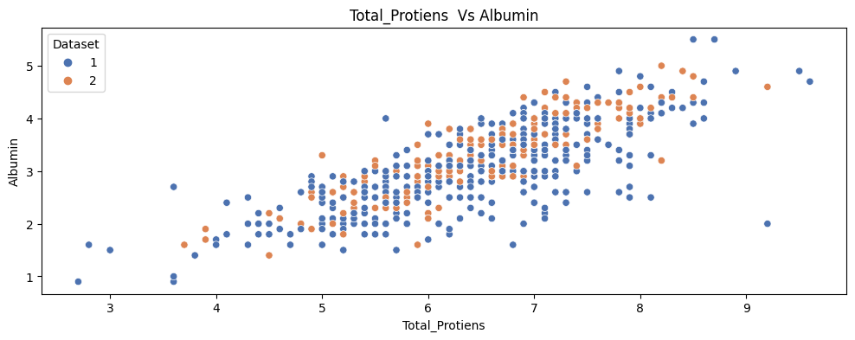

plt.figure(figsize=[12,4])

sns.scatterplot(x = data['Total_Protiens'],y=data['Albumin_and_Globulin_Ratio'],hue=data['Dataset'],palette='deep')

plt.title('Total_Protiens Vs Albumin_and_Globulin_Ratio')

plt.show()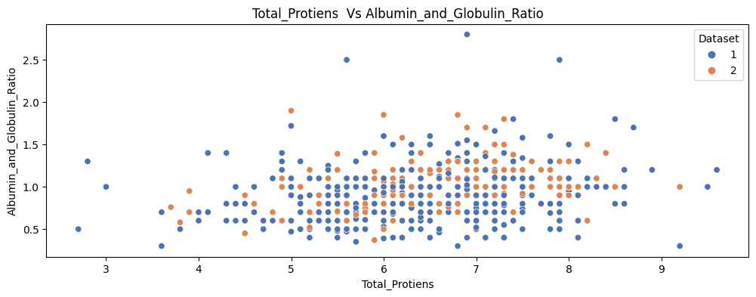

plt.figure(figsize=[12,4])

sns.scatterplot(x = data['Albumin'],y=data['Albumin_and_Globulin_Ratio'],hue=data['Dataset'],palette='deep')

plt.title('Albumin Vs Albumin_and_Globulin_Ratio')

plt.show()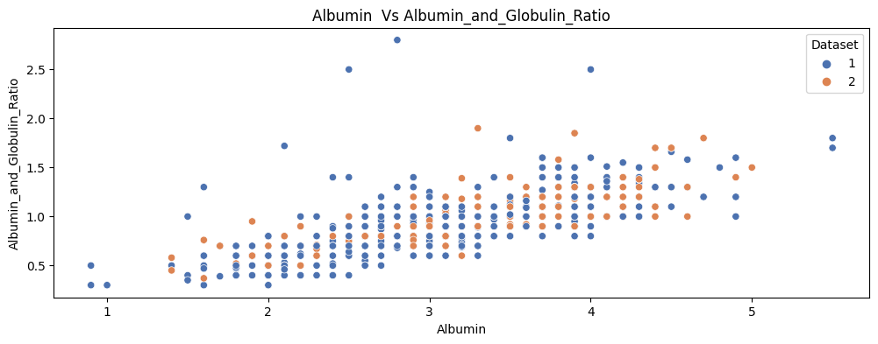

*#plot 1:*

plt.subplot(1, 2, 1)

sns.set_style("whitegrid")

sns.boxplot(x = 'Dataset', y = 'Total_Bilirubin', data = data)

*#plot 2:*

plt.subplot(1, 2, 2)

sns.set_style("whitegrid")

sns.boxplot(x = 'Gender', y = 'Total_Bilirubin', data = data)

plt.tight_layout()

plt.suptitle("Boxplot for Total_billirubin")

plt.show()

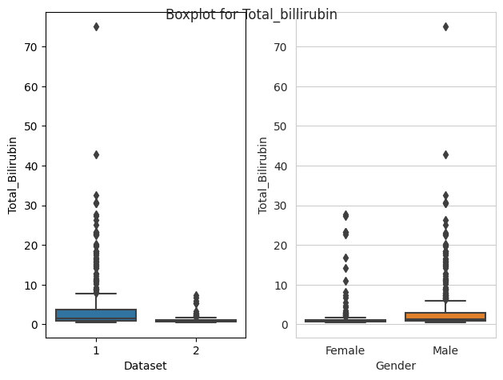

*#plot 1:*

plt.subplot(1, 2, 1)

sns.set_style("whitegrid")

sns.boxplot(x = 'Dataset', y = 'Total_Bilirubin', data = data)

*#plot 2:*

plt.subplot(1, 2, 2)

sns.set_style("whitegrid")

sns.boxplot(x = 'Gender', y = 'Total_Bilirubin', data = data)

plt.tight_layout()

plt.suptitle("Boxplot for Total_billirubin")

plt.show()

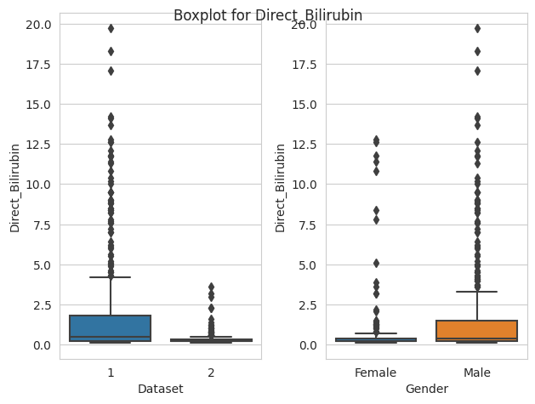

*#plot 1:*

plt.subplot(1, 2, 1)

sns.set_style("whitegrid")

sns.boxplot(x = 'Dataset', y = 'Alkaline_Phosphotase', data = data)

*#plot 2:*

plt.subplot(1, 2, 2)

sns.set_style("whitegrid")

sns.boxplot(x = 'Gender', y = 'Alkaline_Phosphotase', data = data)

plt.tight_layout()

plt.suptitle("Boxplot for Alkaline_Phosphotase")

plt.show()

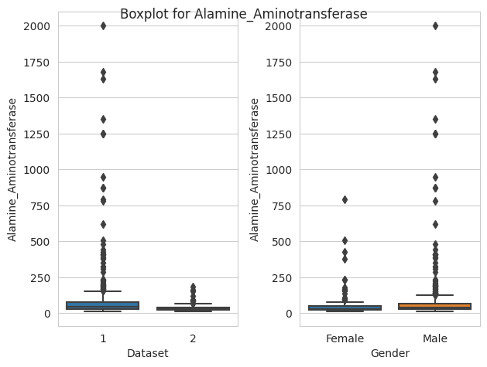

*#plot 1:*

plt.subplot(1, 2, 1)

sns.set_style("whitegrid")

sns.boxplot(x = 'Dataset', y = 'Alkaline_Phosphotase', data = data)

*#plot 2:*

plt.subplot(1, 2, 2)

sns.set_style("whitegrid")

sns.boxplot(x = 'Gender', y = 'Alkaline_Phosphotase', data = data)

plt.tight_layout()

plt.suptitle("Boxplot for Alkaline_Phosphotase")

plt.show()

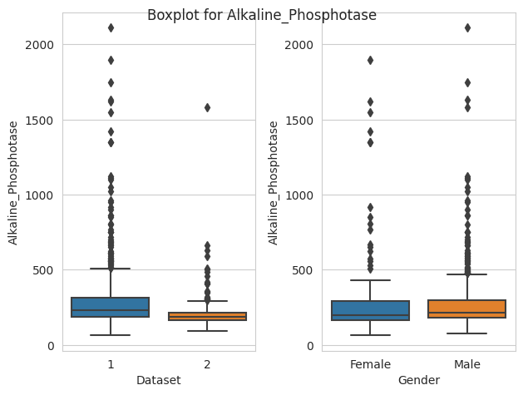

*#plot 1:*

plt.subplot(1, 2, 1)

sns.set_style("whitegrid")

sns.boxplot(x = 'Dataset', y = 'Aspartate_Aminotransferase', data = data)

*#plot 2:*

plt.subplot(1, 2, 2)

sns.set_style("whitegrid")

sns.boxplot(x = 'Gender', y = 'Aspartate_Aminotransferase', data = data)

plt.tight_layout()

plt.suptitle("Boxplot for Aspartate_Aminotransferase")

plt.show()



*#plot 1:*

plt.subplot(1, 2, 1)

sns.set_style("whitegrid")

sns.boxplot(x = 'Dataset', y = 'Total_Protiens', data = data)

*#plot 2:*

plt.subplot(1, 2, 2)

sns.set_style("whitegrid")

sns.boxplot(x = 'Gender', y = 'Total_Protiens', data = data)

plt.tight_layout()

plt.suptitle("Boxplot for Total_Protiens")

plt.show()

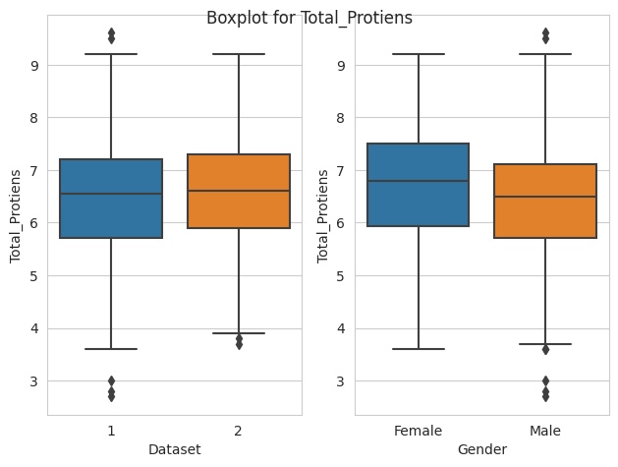

*#plot 1:*

plt.subplot(1, 2, 1)

sns.set_style("whitegrid")

sns.boxplot(x = 'Dataset', y = 'Albumin', data = data)

*#plot 2:*

plt.subplot(1, 2, 2)

sns.set_style("whitegrid")

sns.boxplot(x = 'Gender', y = 'Albumin', data = data)

plt.tight_layout()

plt.suptitle("Boxplot for Albumin")

plt.show()

*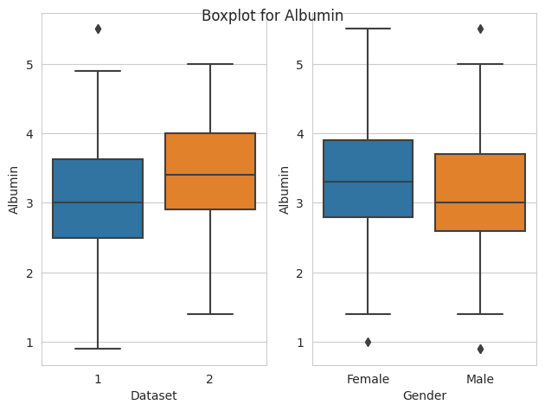#plot 1:*

plt.subplot(1, 2, 1)

sns.set_style("whitegrid")

sns.boxplot(x = 'Dataset', y = 'Albumin_and_Globulin_Ratio', data = data)

*#plot 2:*

plt.subplot(1, 2, 2)

sns.set_style("whitegrid")

sns.boxplot(x = 'Gender', y = 'Albumin_and_Globulin_Ratio', data = data)

plt.tight_layout()

plt.suptitle("Boxplot for Albumin_and_Globulin_Ratio")

plt.show()

